Customer complaint process |  |  |  |  |  |  |  |  |  | 
Document no |  |  | RS-COP-07 |  |  |  |  | Written by |  |  |  | Mark.Kim
Rev no |  |  | 001
Rev. date | 2022.10.04 |  |  |  |  |  |  | Department |  |  |  | QM
Revised contents |  |  |  |  |  | Drift |  |  | Review |  |  |  | Approval
 |  |  |  |  |  | / |  |  | / |  |  |  | /
Revised Items | AS IS |  |  |  |  | TO BE
Agreement | QM | R&D
 | Opinion:

[Revision history]
Revision history summary |  |  | RS-COP-07
 |  |  | Revision | 001
 |  |  | Confidential | G1
Rev. no | Rev. date | Simple description of changed contents | Author | Post
001 | 2022.10.04 | Newly established. | Mark.Kim | QM

1. Purpose and scope
The purpose of this procedure is to handle for customer complaint when is issued complaint point a view of quality & environment from customer. This procedure is defined each role to solve customer complaint.

2. Apply scope
All of complaint issue from customers.

3. Definition of terms
3.1 Customer complaint
Quality & environment issue of the shipped product to the customer.
(ex/ Escape of the defect product, Shipped product’s defect, All of defect issue)
3.2 Root cause
Occurrence cause of the issued defect.
3.3 Affect lots.
Suspected range of the defect based on working history or production data.
3.4 Containment action
The temporary action in order to prevent the delivery of additional defects to the customer at customer issue. These actions are made before root cause define.
3.5 Permanent action.
The permanent action in order to prevent reoccurrence defect issue from customer. Permanent actions are made based on actual root cause.
3.6 8D Report
As the efficiency analysis report form. It is composed that is 1D ~ 8D.
1D: Team formation
2D: Problem description
3D: Containment action
4D: Root cause define
5D: Corrective actions
6D: Verification of effectiveness
7D: Prevent recurrence
8D: Approval
3.7 Customer claim
Compensating for customer damage due to defective products.
3.8 Customer complain
There is no monetary compensation for defective products., but analysis and index management are required.

5. Responsibility and authority
5.1 QM head
1) QM leader is responsible for solving customer quality issues.
2) QM leader should inform immediately the customer quality issue to the all of related department to solve customer quality issue.
3) QM leader should survey affect range for customer damage minimize. And then, report them to the customers.
3) QM leader can request corrective action to the relevant department for customer complaint, and the head of the relevant department is responsible for taking the corrective actions.
4) QM leader is responsible for feasibility review of submitted corrective actions from relevant
department. And should implement monitoring whether the corrective action is applied mass production.
5) QM leader should submit corrective action report to the customers, and if there is additional request for corrective action from customers, he have to follow up them.

5.2 Production head
1) Production head is responsible for root cause analyzing, corrective action regarding customer issue.

5.3 Technical engineering head
1) If the defect samples are returned from customer, PE head should implement fail analysis immediately. and then, must define that the defect caused by design issues, production issues. screen ability issues.
2) If it needs to support from relevant department for fail analysis, all of department should support fail analysis.
5.4 Research and development (R&D)
1) If the issued defect from customer is related with chip’s design, R&D head should define root cause, and consider corrective actions.

6. Process mapping
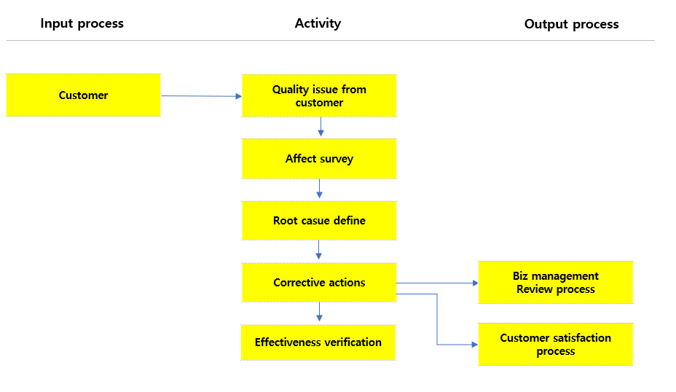
6.1 Fail analysis process
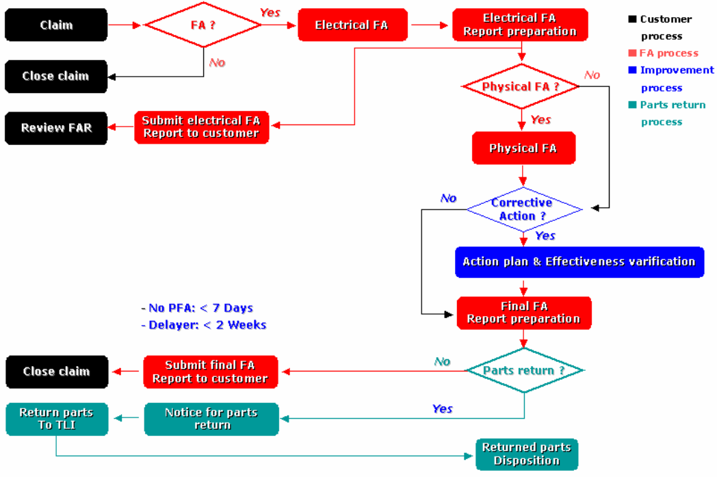

In  process | Input | Activity | Output | Out  process | Freq. | Review | Approval
-. | -. Customer claim letter | -. If the quality trouble is occurred from customer, QM leader should get related information in detail from customer. And then, he should release them to the relevant department for fail analysis.  -. QM leader should survey affect LOT range immediately for customer damage minimize, and have to report them ASAP.  -. QM leader should register the defect history on the RMA Sheet. | -. RMA Sheet | N/A | Occurred | Charged person | CQO
-. | -. RMA sheet | -. Production, technical engineering, and subcontractor analysis the root causes of customer defect materials.  -. QM leader report 4D report to customer if the root cause is reasonable.  -. QM leader should review root cause analyzed from them. And, if it is reasonable, request corrective actions to prevent reoccurrence. | -. FA Report  -. 4D Report | N/A | Occurred | Charged person | CEO
- | -. FA Report  -. 4D Report | -. If it is completed that submit FA or 4D report to the customers, QM leader should prepare corrective action and preventive actions.  -. If the corrective & preventive action is prepared, QM leader implement effectiveness verification on the mass production.  -. If 8D report is prepared, QM’s charged person should submit them to the customers. | -. 8D Report  -. Final FA report | N/A | Occurred | Charged person | CEO
- | -. 8D Report  -. Final FA report | -. If the customer request additional evaluation or verification regarding to the submitted materials, QM’s charged person should follow up customer request for customer satisfaction.  -. QM’s charged person update defect responsibility, TAT, all of information on the RMA sheet | -. Update materials  -. Update RMA sheet | -. Nonconformity management process  -. Biz management review process | Occurred  1x/Month | CQO | CEO

7. Fail analysis TAT
RMA Case | Description | TAT
Urgent | -. Customer sampling inspection defect  -. Customer reliability inspection defect  -. Field issue | 4 days (working day)
Normal | -. Customer’s production line issue except above. | 7 days (working day)
Note: in case of FA TAT, the customer’s standards come first.
Note: RMA (Return merchandise authorization)
8. Document record & preservation
Material | Form code | Dept | Life
Claim index | RS-COP-07-F001 | QM | 5years
RMA index | RS-COP-07-F002 | QM | 5years
RMA Summary | RS-COP-07-F003 | QM | 5years
9. KPI index
Key performance indicator | Equation | Freq. | Department
Claim index | Claim cost / sales amount | 1x/monthly | QM
RMA index | Defect # / shipped amount | 1x/monthly | QM

Appendix
Claim index RS-COP-07-F001
( ) year claim index |  |  |  |  |  |  |  |  |  |  |  |  |  | 
Ⅰ. Field claim index (Compensation) |  |  |  |  |  |  |  |  |  |  | -. Field claim: Customer compensation cost  -. Back order: Retest, defect sorting and scrap cost due to customer defect issue.
Classification |  | D-2 year | D-1 year | Jan | Feb | Mar | Apr | May | Jun | Jul |  | Aug | Sep |  | Oct | Nov | Dec | D amount
Field claim
Back order
Total | Claim cost
 | Sales amount
 | Ratio (%)
Ⅱ. Trend
Trend

RMA index RS-COP-07-F002
( ) year RMA index |  |  |  |  |  |  |  |  |  |  |  |  | 
Ⅰ. RMA index |  |  |  |  |  |  |  |  |  | -. RMA: Return merchandise authorization
Classification | D-2 year | D-1 year | Jan | Feb | Mar | Apr | May | Jun | Jul |  | Aug | Sep |  | Oct | Nov | Dec | D amount
RMA event count
Return volume
Ⅱ. Trend
Trend

RMA summary RS-COP-07-F003
Ⅰ. RMA summary
Date | Device | Issue site  (F: Field)  (M: Production) | Sample # | FA Report # | Classification |  |  |  |  | Simple description
 |  |  |  |  | De-gradation | margin | assembly | escape | mixing

Fail analysis RS-COP-07-F004
Fail Analysis report |  |  |  | 
Ⅰ. General information
Product code |  | Customer
 |  | Issue date
Ⅱ. Customer issue description
Ⅲ. Root cause define
Ⅳ. Corrective actions |  |  |  |  | Due date

